ASSIGNMENT 37

Name : Akanksha Joshi

Roll No : B038

Batch : 3

Div : BTech CS B

-------------------------------------------------------------------------------------------------------------------------

Source Code

try:

num = int(input("Enter number: "))

if num <= 0:

raise ValueError("That is not a positive number!")

except ValueError as ve:

print(ve)

sum = 0

while(num > 0):

sum += num

num -= 1

print("The sum is",sum)

Output

no error

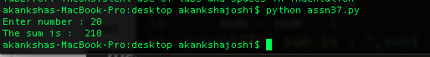

error

